**Querying JSON**

* Json can be viewed in hierarchical fashion as tree  
  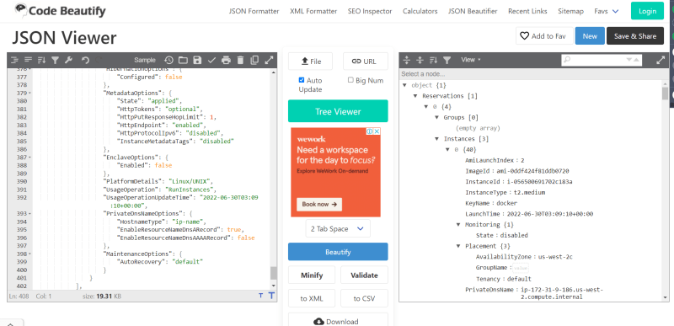
* Find all the vpc ids in your default region  
  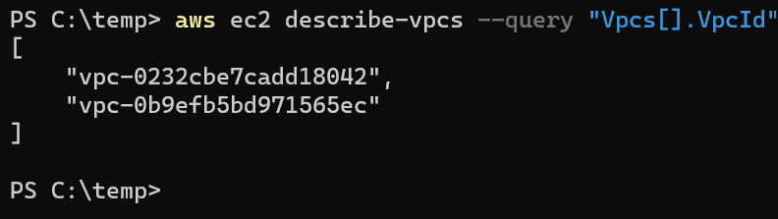
* Find the vpc id of default vpc in default region  
  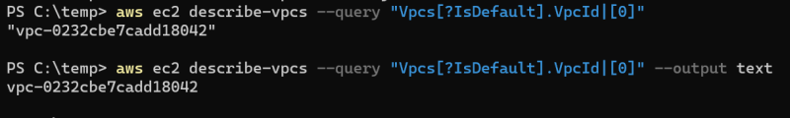
* Find the vpc ids of non-default vpcs in default region  
  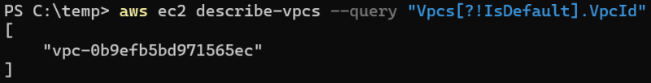
* Find all the subnet ids of the default-vpc in default region  
  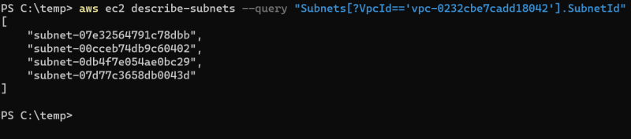  
  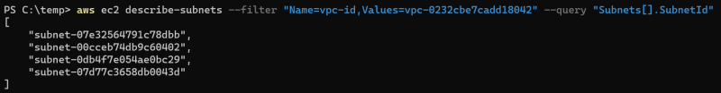
* Find the az’s of all the subnets in default vpc  
  